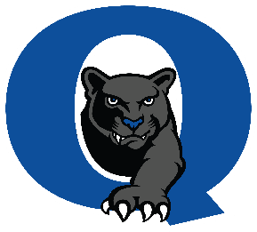
Quakertown Community High School
2022-23 Bell Schedule

1st Period | 8:15 AM | 8:59 AM | 44 min
2nd Period | 9:03 AM | 9:47 AM | 44 min
3rd Period | 9:51 AM | 10:35 AM | 44 min
Lunch / PRIDE | 10:40 AM  11:16 AM | 11:11 AM  11:47 AM | 31 min  31 min
4th Period | 11:52 AM | 12:36 PM | 44 min
5th Period | 12:40 PM | 1:24 PM | 44 min
6th Period | 1:28 PM | 2:12 PM | 44 min
7th Period | 2:16 PM | 3:00 PM | 44 min

AM UBCTS
UBCTS- Travel | 8:10 AM | 8:30 AM
UBCTS Lab | 8:30 AM | 11:00 AM | 130 min
Lunch | 10:40 AM | 11:00 AM
UBCTS Travel | 11:05 AM | 11:30 AM
Transition | 11:35 AM | 11:47 AM | 12 min.
4th Period | 11:52 AM | 12:36 PM | 44 min
5th Period | 12:40 PM | 1:24 PM | 44 min
6th Period | 1:28 PM | 2:12 PM | 44 min
7th Period | 2:16 PM | 3:00 PM | 44 min

PM UBCTS
1st Period | 8:15 AM | 8:59 AM | 44 min
2nd Period | 9:03 AM | 9:47 AM | 44 min
3rd Period | 9:51 AM | 10:35 AM | 44 min
UBCTS- Travel | 10:40 AM | 11:00 AM
Lunch | 11:05 AM | 11:25 AM
UBCTS Lab | 11:30 AM | 2:15 PM | 165 min
UBCTS Travel | 2:20 PM | 2:40 PM

PM UBCTS – 10th Grade ONLY
1st Period | 8:15 AM | 8:59 AM | 44 min
2nd Period | 9:03 AM | 9:47 AM | 44 min
3rd Period | 9:51 AM | 10:35 AM | 44 min
PRIDE Class | 10:40 AM | 11:11 AM | 31 min.
Lunch | 11:16 AM | 11:36AM
UBCTS- Travel | 11:40 AM | 12:00 PM
UBCTS Lab | 12:00 PM | 2:15 PM | 135 min
UBCTS Travel | 2:20 PM | 2:40 PM

